Project 1

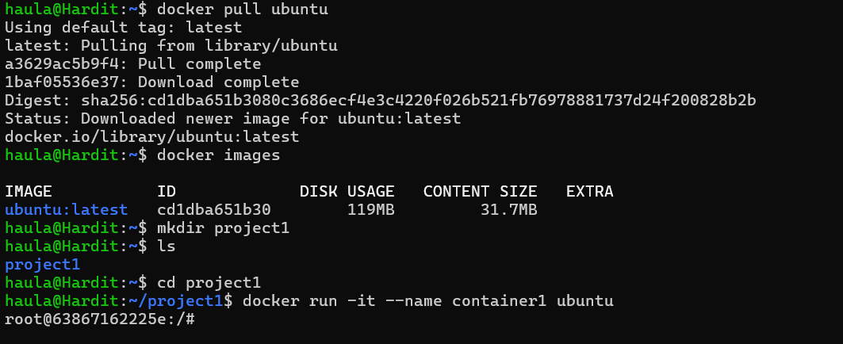
- docker pull ubuntu : this command pulls the latest ubuntu image from the docker hub.
- Docker images : shows all images installed and brief info.
- Mkdir project1 : creates a directory called project1
- Cd project1 : navigate to the directory project1
- Docker run -it –name container1 ubuntu : this command creates our first container using the image ‘ubuntu’. -it flag starts the container in interactive mode. --name allows us to name the container.

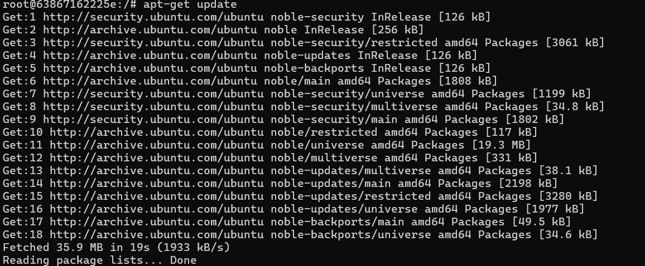
- apt-get update : this command is used to update the package index files on the system, which contain information about their available packages and their versions.

- this command is used to install the open ssh-server in container 1.

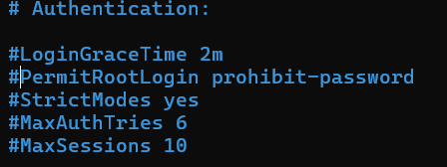
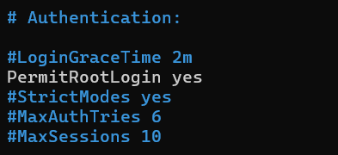
- here we need to do some simple ssh configuration.
- We access the sshd_config file using the test editor nano.
- Uncomment the PermitRootLogin and change prohibit-password to yes.

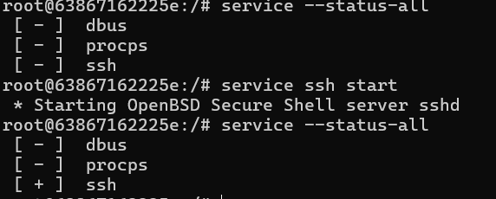
- To enable the ssh server in container 1.
- Service –status-all : used to check the status of every service installed.
- Service ssh start : starts ssh

- We follow the same steps as before to create container 2. Run apt-get update in the container.
- This time we instal openssh-client instead of server

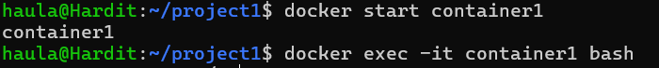
- Now we need to set a root password for our server, i.e. container1
- First we exit container using ‘exit’ command
- Start container1 again using ‘docker start’
- The docker exec command runs a new command in a running container.
- Cat command is used to view, read anything in the /etc/shadow . we combine this using the pipe function with grep, which is used to grab specific text phrases in files. Here we are looking for the root password.

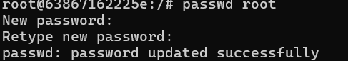
- We use this command to update the root password.

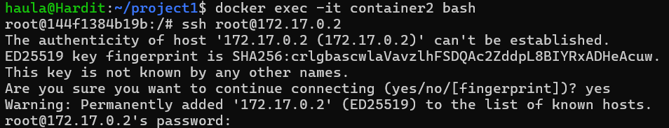
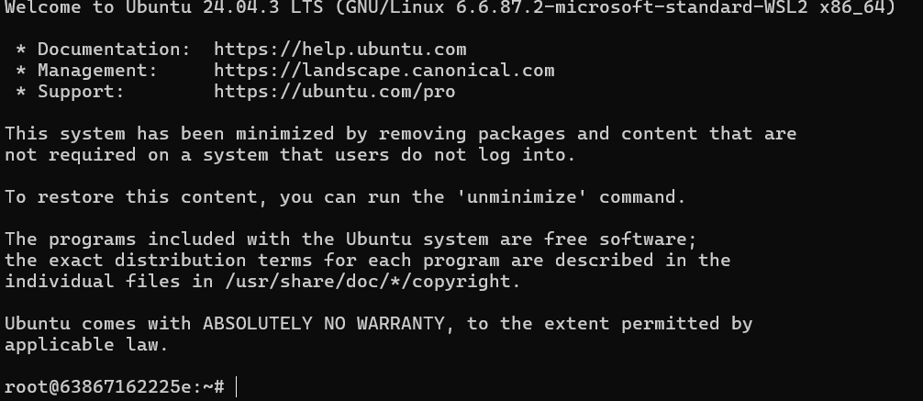

- Now first we exit container 1
- We run docker inspect on container1 and pipe to grep to grab the ipaddress of the container, as without that we cant ssh into the container.
- We use the docker start command to start container2 and then enter it using the same command as before, docker exec bash
- Now we run the ssh command to enter into container1 from container2 using its ipaddress.
- On the password prompt, we enter the password that we set earlier.
- Voila!
Note : if the ssh connection command shows connection refused, it is likely that container1 ssh service is not running, so make sure to check and start ssh server in container1.

